Can you make some validation so the rules in the () are upheld? These should not be allowed to be the same value, they have to increase for each level.

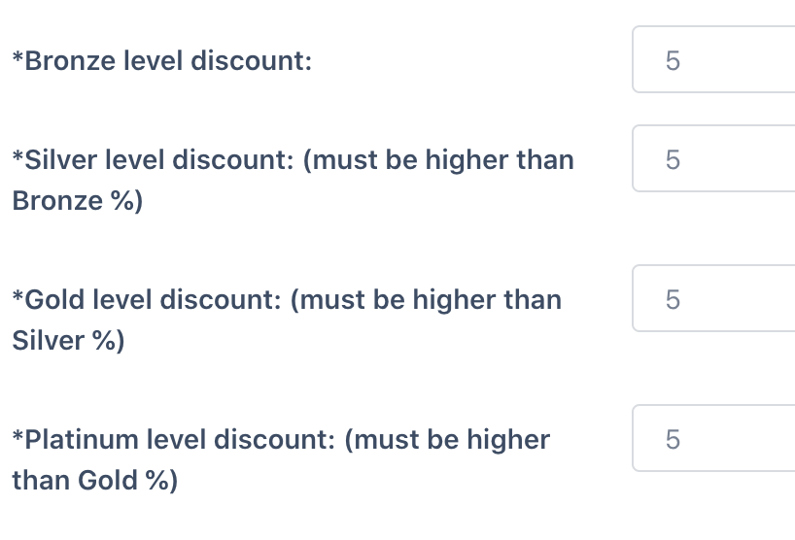

I still can’t go back or Refresh in browser:

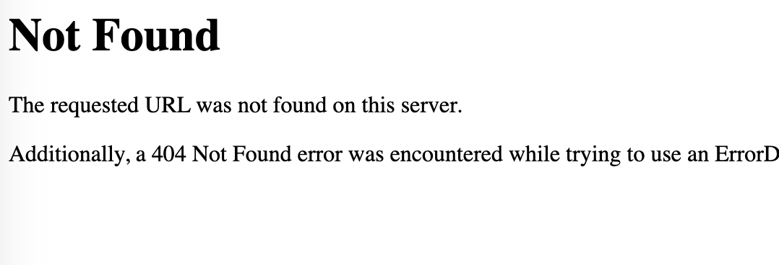

In users, “name” should be removed yes?   
